# Logger/Dump Configuration:

<EnableLogging>YYYY</EnableLogging> or <EnableLogging>YY</EnableLogging>

<EnableDump>YYYY</EnableDump> or <EnableDump>YY</EnableDump>

1. In case of 4 characters, it corresponds to following in that order
   1. Request (REQ)
   2. Internal Request (IREQ)
   3. Internal Response (IRES)
   4. Response (RES)
2. In case of 2 characters, it corresponds to following in that order
   1. Request (REQ)
   2. Response (RES)

Each character of them corresponds to enabling or disabling the logging for this part of the request

# ESB Events:

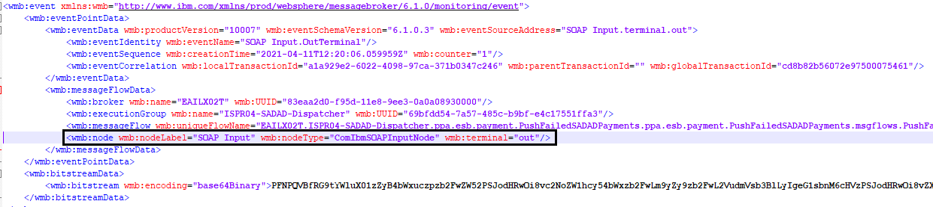

**Cases:**

1. REQ:
   1. **“nodeType”** contains **“Input”** **OR**
   2. **“nodeLabel”** contains **“exception”** or **“catch”**
2. IREQ:
   1. **“nodeType”** contains **“Request” AND**
   2. **“nodeTerminal”** contains **“in”**
3. IRES:
   1. **“nodeType”** contains **“Request” AND**
   2. **“nodeTerminal”** does not contains **“in”**
4. RES:
   1. **“nodeType”** contains **“Reply”**

# DP Events:

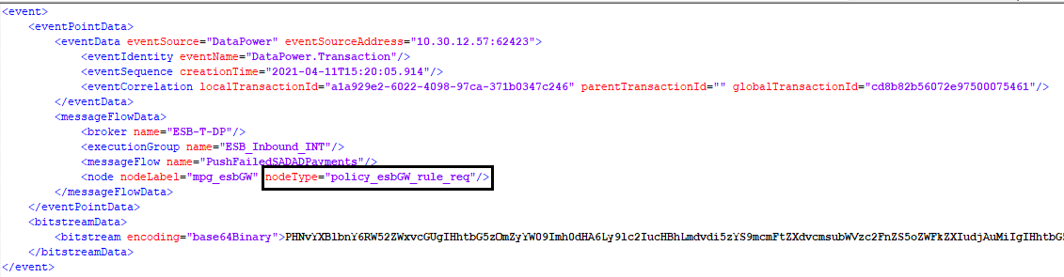

**Cases:**

1. REQ:
   1. **“nodeType”** contains **“_REQ”** or **“_RQ”**
2. RES:
   1. **“nodeType”** contains **“_RES”** or **“_RS”** or **“_ERR”** or **“_FAULT”**